

INFORMATION TECHNOLOGY EDUCATION DEPARTMENT

ITPROG2
(Computer Programming 2 for IT)

EXERCISE
3

Character and String Manipulation

score

Justine Guillermo  Name of Student | Jay-Ar Lalata  Name of Professor
Feb 12 2019  Date Performed | Date Submitted

LABORATORY EXERCISE 3

Table 1: Some Predefined C-String Functions in <cstring>

FUNCTION | DESCRIPTION
strcpy(Target_String_Var,Src_String) | Copies the C-string value Src_String into the C-string variable Target_String_Var
strcpy(Target_String_Var,Src_String,limit) | The same as the two argument strcpy except that at most Limit characters are copied
strcat(Target_String_Var,Src_String) | Concatenates the C-String value Src_String onto the end of C-string in the C-string variable Target_String_Var
strcat(Target_String_Var,Src_String, Limit) | The same as the two argument strcat except that at most Limit characters are appended.
strlen(Src_String) | Returns an integer equal to the length of Src_String. (The null character, ‘\0’, is not counted in the length.
strcmp(String_1, String_2) | Returns 0 if String_1 and String_2 are the same. Returns a value < 0 if String_1 is less than String_2. Returns a value > 0 if String_1 is greater than String_2 (that is, returns a nonzero value if String_1 and String_2 are different). The order is lexicographic.
strcmp(String_1, String_2, Limit) | The same as the two-argument strcmp except that at most Limit characters are compared.

Character-Manipulating Functions

Table 2 : Some functions in <cctype>
FUNCTION | DESCRIPTION
toupper(Char_Exp) | Returns the uppercase version of Char_Exp (as value of type int).
tolower(Char_Exp) | Returns the lowercase version of Char_Exp (as value of type int).
isupper(Char_Exp) | Returns true provided Char_Exp is an uppercase letter; otherwise, returns false.
islower(Char_Exp) | Returns true provided Char_Exp is an lowercase letter; otherwise, returns false.
isalpha(Char_Exp) | Returns true provided Char_Exp is a letter of the alphabet; otherwise return false.
isdigit(Char_Exp) | Returns true provided Char_Exp is one of the digits ‘0’ through ‘9’; otherwise, returns false.
isalnum(Char_Exp) | Returns true provided Char_Exp is either a letter or a digit; otherwise, returns false.
isspace(Char_Exp) | Returns true provided Char_Exp is a whitespace character, such as the blank or newline character, otherwise, return false.
ispunct(Char_Exp) | Returns true provided Char_Exp is a printing character other than whitespace, a digit, or a letter; otherwise return false.
isprint(Char_Exp) | Returns true provided Char_Exp is a printing characters includes blank space; otherwise returns false.
isgraph(Char_Exp) | Returns true provided Char_Exp is a printing characters; otherwise returns false.
isctrl(Char_Exp) | Returns true provided Char_Exp is a control character; otherwise, return false.

A) C-String User defined functions

PROBLEM #1
Convert the predefined function strcmp() to user defined function.
Note: strcmp() returns three values based on the lexicographical order of the characters based on the ASCII table

EXAMPLE PROGRAM OUTPUT:
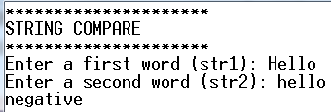 | 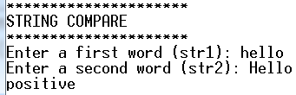
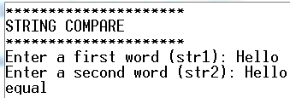

Program:
#include <iostream>
#include <cstring>

using namespace std;
void compare (char str1[50],char str2[50]){
if ((strcmp (str1,str2))==0)
cout << "Equal";
else if ((strcmp (str1,str2))>=0)
cout << "positive";
else
cout << "Negative";

}

int main(){
char str1[50],str2[50];
cout <<"******************"<<endl;
cout <<"STRING COMPARE"<<endl;
cout <<"******************"<<endl;
cout <<"Enter a First Word (str1): ";
cin >> str1;
cout <<"Enter a Second Word (str2): ";
cin >> str2;
compare (str1,str2);
return 0;
}
Sample Output:

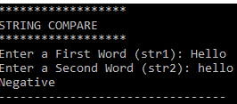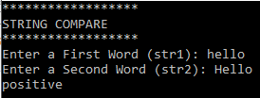
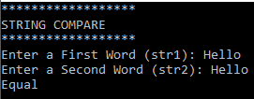

PROBLEM #2
Convert the predefined function strcpy() to user defined function.

EXAMPLE PROGRAM OUTPUT:
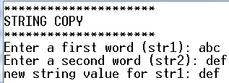 | 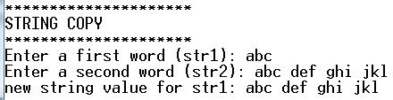

Program:
#include <iostream>
#include <cstring>

using namespace std;
void copy(char str1[50],char str2[50]){

strcpy (str1,str2);
cout << str1;

}
int main(){
char str1[50],str2[50];
cout <<"******************"<<endl;
cout <<"STRING COPY"<<endl;
cout <<"******************"<<endl;
cout <<"Enter a First Word (str1): ";
cin.getline(str1,50);
cout <<"Enter a Second Word (str2): ";
cin.getline(str2,50);
copy(str1,str2);

}
Sample Output:
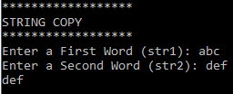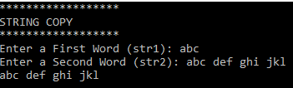

PROBLEM #3
Convert the predefined function strcat() to user defined function.

EXAMPLE PROGRAM OUTPUT:
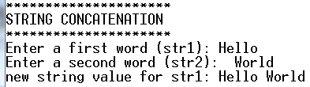 | 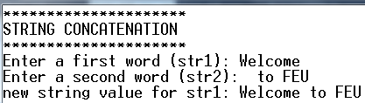

Program:
#include <iostream>
#include <cstring>

using namespace std;
void concat(char str1[50],char str2[50]){
strcat (str1,str2);
cout << str1;

}
int main(){
char str1[50],str2[50];
cout <<"******************"<<endl;
cout <<"STRING CONCATENATION"<<endl;
cout <<"******************"<<endl;
cout <<"Enter a First Word (str1): ";
cin.getline(str1,50);
cout <<"Enter a Second Word (str2): ";
cin.getline(str2,50);
concat(str1,str2);

}
Sample Output:
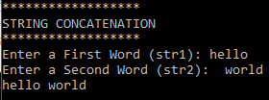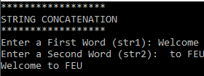

B) Character Manipulation and String Class

PROBLEM #4
Create a program that will capitalize each word from the string input.

EXAMPLE PROGRAM OUTPUT:
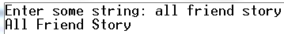 | 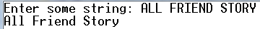
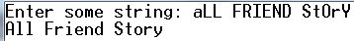

Program:
#include <iostream>
#include <cstring>

using namespace std;

int main(){
char str1[50],str2;

cout <<"Enter a string: ";
cin.getline(str1,50);
str2 = toupper(str1[0]);
cout << str2;
for (int i=0;i<=strlen(str1);i++){

if (isspace(str1[i])){
str2=toupper(str1[i+1]);
cout << str2 ;

}
else if (isspace(str1[i])!=1) {
str2=tolower(str1[i+1]);
cout <<str2;
}
}

}

Sample Output:
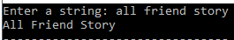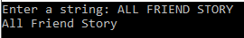
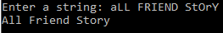

PROBLEM #5
Create a program that will ask the user to enter some string. The program will split the string in to word and display in reverse vertical order.

Program:

Sample Output:

EXAMPLE PROGRAM OUTPUT:
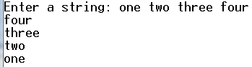 | 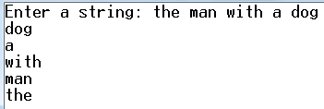

Program:
#include <iostream>
#include <cstring>

using namespace std;

void reverse(char* sentence)
{
int i = strlen(sentence) - 1,h,l = '\0';

while (i >= 0){
while (i>=0 && sentence[i] != ' ')
i--;
h = i - 1;
i++;

while (sentence[i] != l){
cout << sentence[i];
i++;
}
l = ' ';
i = h;

if(i > 0)
cout<<endl;
}

}
int main()
{
cout<<"enter a string: ";
char* sentence = new char[256];
cin.getline(sentence, 256);
reverse(sentence);
return 0;
}

Sample Output:
